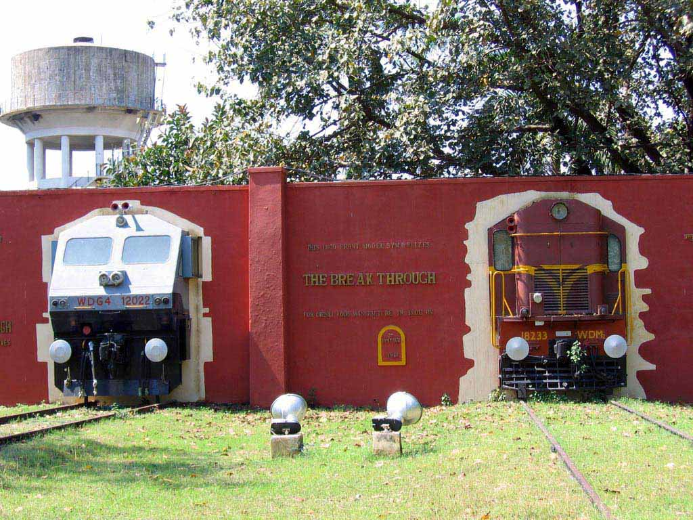

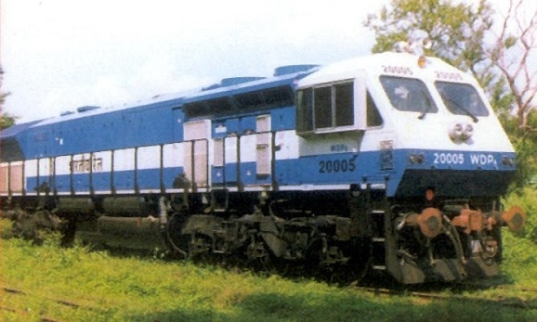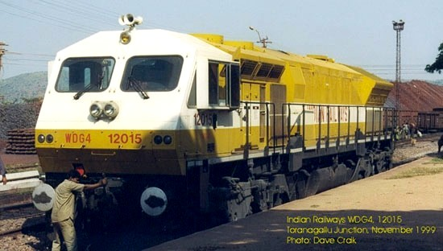

Summer training report

on  
 BANARAS locomotive works

Varanasi

Summer training report

on  
 BANARAS locomotive works

Varanasi

**Name :- Vijay Bhsuahan Singh**

**Reg. No. :- 2024OF0013**

**Course :- B. Tech in ECE**

**Branch :- Electronics & Communication Engineering**

**Training Date :- 04/06/2024 to 01/07/2024**

**Training Area :- SCADA, TAS, Tele. Exchange, LAS**

**INDIAN INSTITUTE OF INFORMATION TECHNOLOGY, SENAPATI, MANIPUR**

**Jitendra Agarwal**

**Principal**

**Technical Training Center**

**BLW, Varanasi**

**221004**

**SUBMITTED TO SUBMITTED BY**

**Acknowledgement**

This project report is combined effort of many people who have contributed in there own ways in making this report effective and purposeful. In my report, I would like to take the opportunity of thanking all those who have been instrumental in preparing this report.

I would sincerely like to thank the employees and the officers of BLW, Varanasi for their help and support during the vocational training, Despite their busy schedules, they took time out and explained to us the various aspects of the working of the plant and technological knowhow.

I would sincerely like to thank Mr. D. D. Pandey[SSE(SCADA)], and other JE’s and SSE’s who were instrumental in arranging the vocational training at BLW Varanasi, and without whose help and guidance could not have materialized.

I express my deep sense of gratitude to Jitendra Agarwal (Principal, TTC) for giving me such a great opportunity.

I also extend my heartfelt thanks to my family & well wishers.

**Preface**

The objective of the practical training are to learn something about industries practically and to be familiar with the working style of a technical person to adjust simply according to the industrial environment.

It is rightly said practical life is far away from theoretical one. We learn in class room can give the practical exposure or real life experience no doubt they help in improving the personality of the student in long run of life and will be able to implement the theoretical knowledge.

As, a part of academic syllabus of four year degree course in Electronics and Communication Engineering, every student is required to undergo a practical training. I am a student of second year Electronics and Communication Engineering and this report is written by me on the basis of practical knowledge acquired by me during the period of practical training taken at Banaras Locomotive Works(BLW).

**Introduction to BLW**

BLW, was founded by Late Railway Minister Mr. Lal Bahadur Shastri on 23 April 1956. It is spread in 300 acres area at Varanasi. It is a production unit owned by Indian railways , for which it manufactures diesel–electric locomotives and its spares parts. It is the largest diesel-electric locomotive manufacturer in India. To meet the increased transportation needs of the Indian railways it was established in collaboration with ALCO( American Locomotive Company), USA in 1961. BLW rolled out its first locomotive three years later, on January 3, 1964. It manufactures locomotives. Got its first ISO certification in 1997 and ISO-9001 and ISO-14001 in December 2002. With technology transfer agreement from manufacturers such as GM-EMD, BLW today produces advance locomotives having output range from 2600 to 4000 hp. At present the latest locomotive produced by BLW; i.e. WDG 5 has capacity upto 5000 HP & trying to make it 5500 HP. It has supplied locomotives to other countries such as Sri Lanka, Bangladesh, Malaysia, Tanzania and Vietnam etc. BLW is supplying locos to PSU’s & Industries Like NTPC, COAL, INDOGULF etc. Founded in 1961, the BLW rolled out its first locomotive three years later, on January 3, 1964. It manufactures locomotives which are variants based on the original ALCO designs dating to 1960s and the GM EMD designs of the 1990s. BLW has an annual production capacity of 200 locomotives and plans to increase it to 270 based on the current demand.

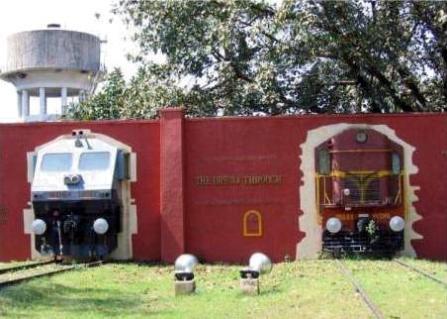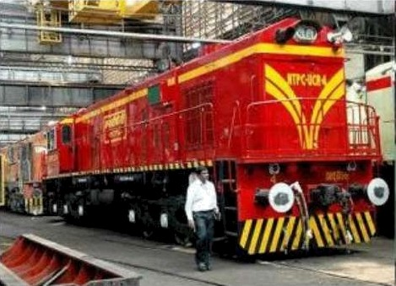

Banaras Locomotive Works (BLW) is a production unit under the ministry of railways. This was setup in collaboration with American Locomotive Company (ALCO), USA in 1961 and the first locomotive was rolled out in1964. This unit produces diesel electronic locomotives and DG sets for Indian railways and other customers in India and Abroad. Subsequently a contract for transfer of technology of 4000 HP Microprocessor Controlled AC/AC Freight (GT 46 MAC) / passenger (GT46 PAC) locomotives and family of 710 engines has been signed with electromotive division of GENERL MOTORS of USA for manufacture in BLW. The production of these locomotives has now started and thus BLW is the only manufacturers of Diesel Electric Locomotives with both ALCO and General Motors technologies in the world.

* **Brief History**
* Set up in 1961 as a green-field project in technical collaboration with ALCO/USA to Manufacture Diesel Electric Locomotives.
* First locomotive rolled out and dedicated to nation in January, 1964.
* Transfer-of-Technology agreement signed with General Motors/ USA in October, 95 to manufacture state-of-the-art high traction AC-AC diesel locomotives.
* A flagship company of Indian Railways offering complete range off tanking products in its area of operation.
* State-of-the art Design and Manufacturing facility to manufacture more than 150 locomotives per annum with wide range of related products viz. components and sub-assemblies.
* Unbeatable trail-blazing track record in providing cost-effective, eco-friendly and reliable solutions to ever-increasing transportation needs for over three decades
* Fully geared to meet specific transportation needs by putting Price-Value-Technology equation perfectly right.
* A large base of delighted customers among many countries viz. Sri Lanka, Malaysia, Vietnam, Bangladesh, Tanzania to name a few, bearing testimony to product leadership in its category.
* **SALIENT FEATURES**
* Annual production capacity 125 Locomotives
* Annual turn-over (Rs) 5000 million
* Total number of staff 7223
* Workshop land 89 Hectares
* Township area 211 Hectares
* Covered area in shops 86300 m^2
* Covered area of other service buildings 73700 m^2
* Electrical power requirement 3468 KVA(Average maximum demand)
* Electrical energy consumption (units/year) 19.8 million
* Standby power generation capacity 3000 KW
* **PRODUCT OF BLW**

BLW is an integrated plant and its manufacturing facilities are flexible in nature. These can be utilized for manufacture of different design of locomotives of various gauges suiting customer requirements and other products. The product range available is as under:

* WDG4 4000 HP AC/AC Freight Traffic Locomotive
* WDP4 4000 HPAC/AC Broad Gauge High Speed Locomotive
* WDG3D 3400 HP AC/AC Broad Gauge Mixed Traffic Micro-Processor Controlled Locomotive.
* WDM3C 3300 HP AC/DC Broad Gauge Mixed TrafficLocomotive.WDM3A 3100 HP AC/DC Broad Gauge Mixed TrafficLocomotive.WDP3A 3100 HP AC/DC Broad Gauge High Speed Passenger Locomotive.
* WDG3A 3100 HP AC/DC Broad Gauge Freight Locomotive.
* WDM2 2600 HP AC/DC Broad Gauge Mixed Traffic Locomotive.
* WDP1 2300 HP AC/DC Broad Gauge Intercity Express Locomotive.WDM7 2150 HP DC/DC Broad Gauge Mixed Traffic Locomotive.
* WDM6 1350 HP DC/DC Broad Gauge Mixed Traffic Locomotive.
* YDM4 1350 HP AC/DC & DC/DC Broad Gauge Mixed traffic Locomotive.
* EXPORT LOCO 2300 HP AC/DC Meter Gauge/Cape gauge Mixed Traffic Locomotive.
* Diesel Generating Sets 800 KW to 2500 KWSpare Parts for engines, locomotives and generating sets.
* **DESIGN OFFICE**

Prepare diag. of each part and sent to Material Control & inform timely in any change in any parts to relative department.

3D MODEL OF DIESEL LOCO MOTIVE

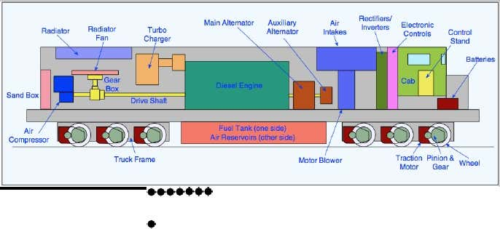

* **MATERIAL CONTROL OFFICE**

Prepared material list (ml) which consists diag. & qty. of each part and sent tostore departments for purchase.

FORK LIFT TRUCK

* **STORE DEPARTMENT**

After receiving of ML, Store Departments scrutiny the ML, take Funds &vetting from Account department & then issue tenders, Open Tenders &Purchase Order issued. After Receiving of Material inspection has done by Inspection Department.

* **INSPECTION DEPARTMENT**

After Receiving of Material inspection has done by Inspection department. If material is OK then Receipt Note issued by Store department and sent to Acct. Department for payment to firm. If material is not OK Then inform to firm to collect the rejected material.

* **ACCOUNT DEPARTMENT**

Check all the purchase, given concurrence for purchase, vett the ML/Requisition & payment to firms.

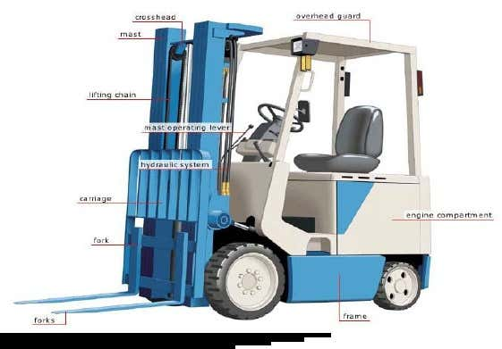

* **PLANNING OFFICE**

Prepare JPO, Monthly Production Program, Scheduling, Processing, Rate Fixing, Issue Work Orders, Schedule Orders, Issue Job card & other production Documents. Preparing BLW Budget & Sent to Rly Board.

* **PROGRESS OFFICE**

After opening of work orders collect the prod. Documents from PCO and handover to user shop draw the material from depot & given to shop & hand over the ready material of shop to user shop/store. After completion of work, close the work order.

* **ENGINE DIVISION**

**1.** Engine Erection Shop

**2.** Engine Testing Shop

**3.** Light Machine Shop

**4.** Sub Assembly Shop

**5.** Rotor Shop

**6.** Heat Treatment Shop

* **LOCO DIVISION**

**1.** Loco Frame Shop

**2.**Pipe Shop

**3.**Truck Machine Shop

**4.**Traction Assembly Shop

**5.** Sheet Metal Shop

**6.**Loco Assembly Shop

**7.**Loco Paint Shop

**8.**Loco Test Shop

* **BLOCK DIVISION**

**1.** Heavy Weld Shop

**2.** Heavy Machine Shop

* **PRODUCTION SHOPS**

Production shops are divided in three divisions-

**1.** Block Divisions

**2.** Engine Divisions

**3.** Loco Divisions

* **SERVICE SHOPS**

**1.**Maintenance Areas#1, 2, 3

**2.**Tool Room

**3.**Central Transport Shop

* **PERSONNAL DEPARTMENT**

Prepare payment of Staff, Leave Record, Personal Record of every employee, Housing allotment, welfare of staff etc.

* **HEALTH DEPARTMENT**

Having facility of Indoor & Outdoor patients.

* **CIVIL DEPARTMENT**

Maintenance of colony quarters, up gradation of facilities in quarters, sanitation etc.

* **ELECTRICAL DEPARTMENT**

Maintenance of Lighting in quarters and in workshop, electrical works in locomotive etc.

* **RESEARCH &DEVELOPMENT**

1. R & D - A Customer centric Activity Committed to Innovation and Continuous Improvement.

**2.**Highly skilled Manpower capable of handling complete R&D activities;

**3.**A sophisticated design center with modern CAD/ CAE work stations equipped with Unigraphics and Ansys;

**4.**Back-up support from RDSO, a centralized R&D organization at corporate level.

**5.**Several milestones in the past - an enviable pedigree viz many new designs for locomotives such as WDP1, WDG2, WDP2to name a few.

* **MILESTONES ACHIEVED**
* Transfer of technology (TOT) – An added feather in the cap:- Agreement with General Motors of USA for technology transfer to manufacture high horse-power GT46MAC 4000HP AC/AC locomotive in India.
* Only country outside North-America to have this bleeding edge technology.
* Many export/repeat orders complied successfully in recent past and many more in the pipeline.
* Supplied more than 400 locomotives to various non-railway customers.
* Emerging as a leading manufacturer of ALCO/ GM locomotives for developing countries.
* **TECHNICAL TRANING CENTER**

Provide training to all employees at time to time to refresh update their knowledge.

**FUTURE PLANS**

• Assimilation of GM technology to manufacture their latest 710 series of diesel electric locomotives.

• To emerge as a globally competitive locomotive manufacturer.

• To develop as an export hub for ALCO/ GM locos for Asian market.

• To follow an export led growth strategy through continuous. improvement. Cost effectiveness and technology/ product up-gradation as a key to retaining lobal competitiveness by putting price-value-technology equation right.

**WDP4, 4000 HP PASSENGER LOCOMOTIVE**

**General Characteristic**

|  |  |
| --- | --- |
| Installed Power | 4000 HP |
| Axle Load | 19.5 T |
| Gauge | 1676 mm |
| Wheel arrangement | A-A-I I-A-A |
| Wheel diameter | 1092 mm |
| Height | 4201mm |
| Width | 3127 mm |
| Overall Length (Over Buffer Beam) | 19964 mm |
| Weight | 117 T |
| Max tractive effort | 27 T |
| Maximum speed | 160 Kmph |
| Fuel tank capacity | 4000 litres |
| Locomotive Control | EM 2000 with SIBAS-16 Traction Control |

**About the Training**

Banaras Locomotive Works (BLW) has many Workshops for learning and visiting. These workshops are HWS, HMS, EES, ETS, LMS, LAS, EL, SAS,RS, HTS, LFS, PS, TMS, TAS, SMS,MRS, LAS, TE, LPS, SCADA and LTS etc. These are the workshops in the Banaras Locomotive Works (BLW) where student get knowledge about practical experience.

There are some workshops in TTC (Technical Training Centre) like Fitting shop, Machine Shop and Welding Shop.

In Banaras Locomotive Works (BLW) I have visited 4 Works shop in four weeks.

These works shop are SCADA, TAS(Truck Assembly Shop), Telephone Exchange, LAS(Loco Assembly Shop).

**Shop 1 :-SCADA**

Supervisory control and data acquisition (SCADA) is a control system architecture that uses computers, networked data communications and graphical user interfaces for high-level process supervisory management, but uses other peripheral devices such as programmable logic controllers and discrete PID controllers to interface to the process plant or machinery. The operator interfaces which enable monitoring and the issuing of process commands, such as controller set point changes, are handled through the SCADA supervisory computer system. However, the real-time control logic or controller calculations are performed by networked modules which connect to the field sensors and actuators.

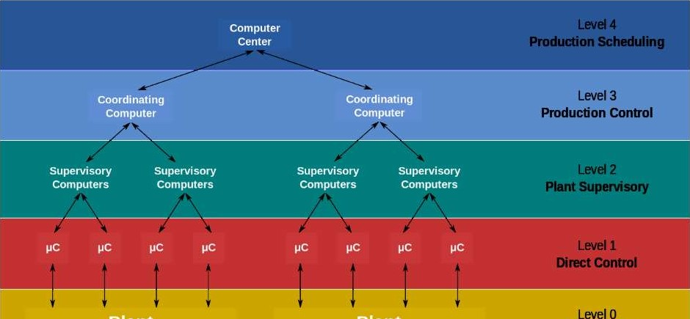

* A SCADA system is used to control physical output through logical input.
* In BLW, SCADA is used to control power flow to all sections in the factory and colony. It is also being upgraded to control motors and all other equipments in the facility.
* The SCADA systems are installed at MRS and all substations and controls are provided accordingly. The MRS SCADA system acts as parent to all other substations, i.e.- It’s commands will override all other substations.

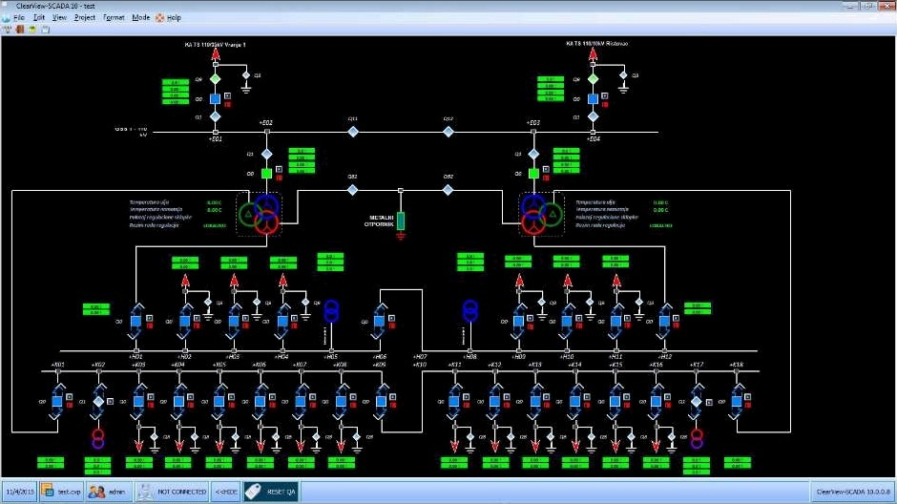

A general SCADA screen showing different equipments and substations.

Supervisory control and data acquisition or simply is SCADA is one of the solutions available for data acquisition monitor and control system covering large geographical area. It refers to the combination of data acquisition and telemetry. SCADA systems are mainly used for the implementation of monitoring and control system of an equipment or plant in several industry like power plant, oil and gas refining, water and waste control, telecommunications etc.

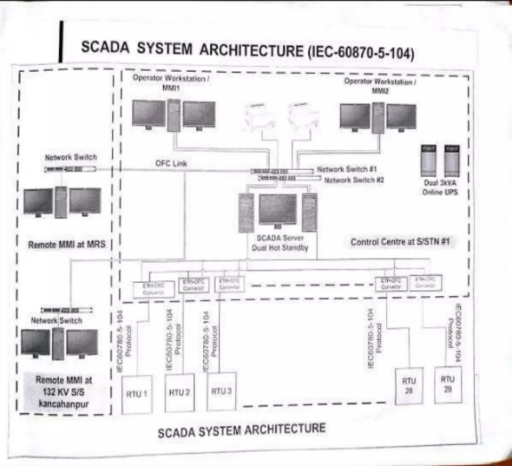

SCADA System Architecture

In this system measurements are made under field or process field in plant by number of remote terminal units and then data transfer to the SCADA Central host computer so that more complete process of manufacturing information can be provided remotely. This system displace the received data on number of operator Prince and conveys back the necessary control access to the remote terminal units in process plant.

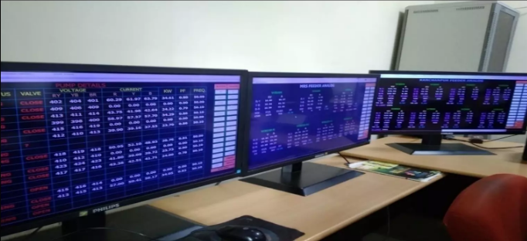

BLW data in SCADA

The major components in SCADA system are :-

* Remote terminal units (RTU's)

RTU is the main component in SCADA system that has a direct connection with the various sensors metres and actuators associated with the control environment. These are nothing but real time programmable logic controller places which are responsible for the properly converting remote station information or digital form for modern to transmit the data and also convert the receipt is signals from master unit in order to control the process equipment through activator and switch boxes.

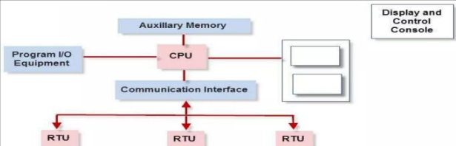

Functional units of SCADA

* Master terminal units (MTUs)

A central host server aur server is called master terminal unit sometime its also called as card as centre it tele-communicate with several RTUs by performing reading and writing operation during schedule planning in edition it performs control alarming networking with other note etc.

* Communication system

The communication network transfer data among Central hose Computer service and the field data interface devices and control unit the medium or transfer can be cable radiod telephone satellite etc or any combination of these.

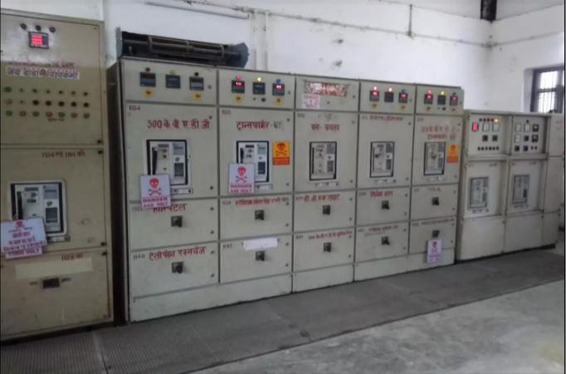

SCADA Control System

* Automation of electrical distribution system

Modern SCADA system replace of manual labour of perform electrical distribution task and manual process in distribution system with automatic equipments. SCADA maximize the efficiency of power distribution system by providing the features like real time view into the operation theatre trading and login maintaining desired voltages current and power factor generating alarms etc.

SCADA performs automatic monitoring protecting and controlling of various equipments and distribution system with the use of intelligent electronic devices or RT use tools the power service during fault condition and also mantain the desired operating conditions.

SCADA improve the reliability of supply by reducing reduction of out ages and also give the cost effective operation of distribution system therefore distribution is card a supervisor the entire distribution system the major function is carda that can be caterers into pollen types substation control feeder control and user load control.

* Operator workstation

These are computer terminals consisting of standard human machine interface software and a network with a central host computer. These workstations are operator terminals that request and send the information to host client computer in order to monitor and control the remote field parameters.

* BLW Ring

Advantages of emplorating card of feature for system for electrical distribution:-

* Due to time recognition of force equipments damage can be avoided.
* Continuous monitoring and control of distribution network is performed from remote location.
* Safe labour caused by limiting manual operation of distribution equipment.
* Reduces the outstand by system wide monitoring and generating alarm for at the problem safely quickly.
* Improve the quantity of server by using service after the occurrence of fault temporary.
* Automatically improves the voltage profile by power factor correction and bar control .

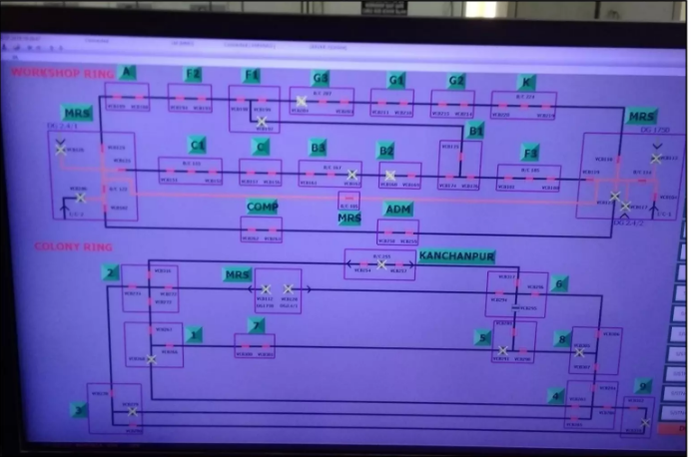

BLW Ring

**Shop 2 :- TAS(Traction Assembly Shop)**

Traction Assembly Shop is the unit in which all locomotive parts are assembled that includes :-

1. CP (Control Panel)
2. Alternator
3. Traction Motors
4. 16 Cylinder Diesel Engine
5. Master Control
6. Cab
7. Auxiliary case exhauster
8. Governor
9. Crank Ease Exhauster
10. Mechanical Assembly

* Control Panel

The Control Panel consists of

1. Control Switch
2. Display Unit
3. LED Panel
4. Microprocessor based control unit
5. Reverser
6. BKT
7. Valves
8. Hooter
9. CK1/CK2/CK3

The top portion of CP has sensors and relays connected to the microprocessor unit.

* The display unit of microprocessor shows working condition of items in engine (electrical equipments apart from engine).
* The LED panel displays the overhead, auxiliary generator failure, hot engine, rectilinear fuse blown, etc.
* The battery ammeter shows the charging state of the batteries.
* REV(Reverser): Field wiring goes to reverser (REV) and hence it is used to control the polarity of the field which in turn controls the direction of train.
* BKT: It is a switch which in one direction is used to motor the loco while in other it is used for dynamic breaking.
* Microprocessor based control unit: on board microprocessors control engine speed, fuel injection, and excitation of the alternator. These computers also interconnect with improved adhesion. An additional function of the microprocessor is to monitor performance of all locomotive systems, thereby increasing their reliability and making the direction of problems easier.
* Hooter: it is a vigilance control device (VCD) to keep the driver alert. If the driver isn’t doing anything with the controls for over a minute the hooter hoots and brigs the engine speed to the normal speed(low) without asking the driver. I can only be reset after 2 minutes and hence the driver will be held responsible for delay in reaching the next station.
* Dynamic braking :- It is the use of electric traction motors of a railroad vehicle as generators when slowing this vehicle. It is termed rheostatic if the generated electrical power is dissipated as heat in brake grid resistors, and regenerative if the power is returned to the supply line. Dynamic breaking lovers the wear of friction based braking components and additionally regeneration can also lower energy consumption.
* During braking, the motor fields are connected across either the main traction generator(diesel-electro loco) or the supply(electrical locomotive) and the motor armatures are connected across wither the brake grids or supply line. The rolling locomotive turn the motor armatures and if the motor fields are now excited, the motors will act as generators.
* For a given direction of travel, current flow through the motor armatures during braking will be opposite to that during motoring. Therefore, the motor exerts torque in a direction that is opposite to that during motoring.
* Therefore, the motor exerts torque in a direction that is opposite from the rolling direction. Breaking effort is proportional to the product of the magnetic strength of the field winding times that of the armature winding.
* In BLW Loco motive the breaking method used is rheostatic, i.e., the traction motors behave as generator (separately excited) and their electrical power is dissipated in break grid resistors. This method is used for minimising speed of the loco. The loco actually comes to a halt due to factors like air resistance, friction with the rail etc.

Alternator

And alternator converts kinetic (energy of motion) into electrical energy. All recently manufactured automobiles rely on alternators to change the battery in the ignition system and supply powered to other electrical equipment. Alternators are sometimes called AC generator because the generate alternating current (AC).

Electrical current can be generated in two ways:-

1. The magnet may rotate inside the coil
2. Or the coil main rotate in a magnetic field created by a magnet

The component that remains stationary is called the stator and the component that moves is called the rotor. In alternator the coil is the status and the magnet is the rotor. The source of mechanical power that is the diesel engine turns the rotor.

In WDM-3D and WDM-3A locos the diesel engine is mechanical output is used to run the shaft of the alternator. The alternating output of the alternator is than rectified to DC wire solid-state rectifiers and is said to traction motor that turn the loco wheels. Thus they operate in AC DC traction mechanism. WDG4 and WDP4 locos have AC-AC traction with microprocessor control i.e., AC traction motors are used as eliminating the motor commutator and brushes the result is the more efficient and reliable drive that requires relatively little maintenance and is better able to cope with overload conditions.

Why not feed DC to the traction motors via DC generators?

In DC generator the roller is the coil alternator normally rotate the magnet which is lighter than the call since alternators are built to spin the letter component instead of 10.

The heavier one, the generally way only one third as much as generator or the same capacity. DC generator, in particular, required more maintenance because of wear on the part that brush against one another in the cummutator switch and the stress of rotating the heaviest component instead of the lightest. Also, when generators are run at higher speed, electricity tends to Arc, or jump the gap separating metal parts. The arching damages parts and could make generous hazardous to touch. Alternators can run at high speed without arcing problems.

Traction motor

It's an electrical motor providing the primary rotational talk to the engine usually for conversion into linear motion (traction). Traction motors are used in electrically power drill vehicles such as electric multiples units and electric , other electric vehicles such as electric milk floods, elevators and conveyor as well as vehicles with electrical transmission system such as diesel-electric and electric hybrid vehicles. Traditionally these are DC series won't matters usually running on approximately 600 volts.

Cylinder diesel engine

It is an internal combustion engine in which heat caused by air compression ignite the fuel. At the instant fuel is injected into a diesel engine combustion chambers, the air inside is hot enough to ignite the fuel on contact. Diesel engine there for do not spark plugs which are required to ignite the air fuel mixture in gasoline engines. The diesel engine has 16 cylinders. Piston inside the cylinder are connected by roads to crankshaft. As the Pistons move up and down in their cylinders, they cause the crankshaft to rotate. The crankshaft rotational force is carried by your transmission to us drive causing mechanical output. Eight 8V and four 2V batteries are used in series to run more powerful starter motor which turns the cracks to ignite ignition and diesel engine for the first time.

Master control

It is the unit that has the handers to regulate the speed of the loco as well as direction of motion. It has numbering from 0 to 9 and each increment causes rise in speed in forward direction. It can also be used to river the direction of motion by posting the handle in the opposite sense. It is present on the control desk of the cab.

Cab

If the driver cabin within 2 control test the control panel (CP) and chairs for the driver. The cab is at the end of the locomotive with the limited visibility if the locomotive is not operated cap forward. each control desk has the independent as a 9 break for breaking of the engine alone and the auto break A9 for the breaking of the entire. It has the following components:-

* LED panel
* Buttons of various engine LED lights (front and size).
* Automatic send through button (to prevent sliding of wheels from inclined tracks).
* Master control
* Gauges to monitor air pressure and fuel and you all pressures.
* Speedometer
* Service break (independent and auto brakes described above) .
* Emergency break (type of air break to hold the train in the distance nearly equal to the length of the train to be used only during an emergency).

Auxiliary generator and exciter

The alternator has these two components. The exciter and authorise generator consists of two armature on a single shaft. The oxygen supply the constant voltage of around 72 volt per supply power to charge. The battery for the control equipment and to power the locomotive light. The title supplies excitation for main generator starting of engine the supply from the battery is given to the exciter the exciter has armature and field welding hence it starts rotating as it received the supply voltage that items coupled with the colour of the alternator which in turn is connected with the propeller shaft. When the propeller rotate at a particular RPM the engine gets started its just like the starting a bike the cake must be a powerful enough to start the engine. Later that engine runs the diesel oil fuel as soon as the engine starts auxiliary generator also couple with the alternator start charging the battery its potential is maintained at -72v.

Mechanical assembly

All mechanical parts on the engine apart from the above mention units maybe group in this category. It essentially consist of :-

* best frame
* wheels
* air breaks
* batteries
* sandbox
* vacuum break
* fuel tank (loco fuel oil tank capacity 3000 litres) etc.

Air breaking system of locomotive: On a train the break shoes are press directly against the wheel rim. A compressor generates air pressure that is stored in a air tanks.

Air hoses connect the break on all train cars into the system. Applying a pressure into the system releases the brains and releasing a pressure from the system applies the track.

Governor

It is the device that has the following function

* To control engine speed.
* Deliver fuel (diesel oil) according to load.
* To meditate electrical demand and diesel engine output.

Crank Tank Exhauster

It is a device used to execute the diesel engine chamber.

**Shop 3-Telephone Exchange**

* Provides telephone connections to the administrative blocks and colony area.
* The exchange works on a D.C. supply of SOV obtained from battery set which is connected in parallel to the charger which is operating on 230V A.C.
* The exchange is designed to perform satisfactorily for line loop resistance of 1000 ohm for each subscriber.
* The voltage required when two subscribers talk is 12V.

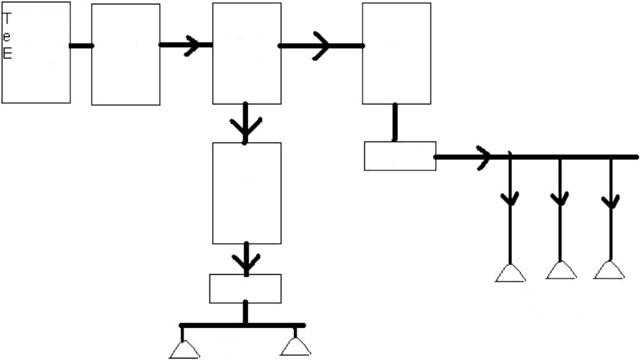

elephon

xchange

I DF

MDF

DB

DP

DB

DP

USER

USER

Block Diagram of Telephone Exchange

Parts in a Telephone exchange:-

*Internal Distribution Frame (IDF) -* In if the framing of jumper is done . The cables which are coming out of the exchange are terminated in IDF and in MDF

*Main Distribution Frame (MDF) -* Exchange is also provided in the rack type of tag block which is called MDF which is the main distribution frame. In MDF we mount the fuse hold tag at the Back of the Block and jumper in front.

*Distribution Board (DB) -* it is the box board in which cable pads are distributed according to the number which are to be provided near the distribution . DB are installed after accretion interval of the distance making a proper distribution of cable which is easier with the consumer.

*Distribution Pole-* Distribution poles are much nearer to the consumer here it is easier to take cables from the consumer.

Faults in a Telephone Exchange:-

There are three types of faults-

Line Contacts — It mean that the drop wire is connected either with a pole or a tree if is broken down and a husky voice is obtain when we ring.

Line Earth — It means that drop wire breaks on its own when it touches a pole or a tree; a soft humming sound comes when we dial a number.

Line Disc - The wire has been broken down.

* Assets in Tele. Exchange
* Communication server system
* Internet system
* PA system
* CCTV cameras
* Television /DTH connections
* PRS
* Communication server system
* AVAYA G650 Rly. Tele-Exch
* GM Intercom Exch.
* BSNL lines
* Video IP phone
* SIP phone
* BSNL lines
* Total nos. of lines- 96
* Connection provided-96 nos.
* AVAYA Tele-Exch
* Up-gradation date- March 2017
* Capacity - 2350 lines (1850 users+500 trunk line)
* User - 1150
* Parts/Component-

1)Server

2)24 port Switch

3)Cabinets

4)Electronics cards

5) Power supply units

6)Cooling system

Tele-Exch block diagram

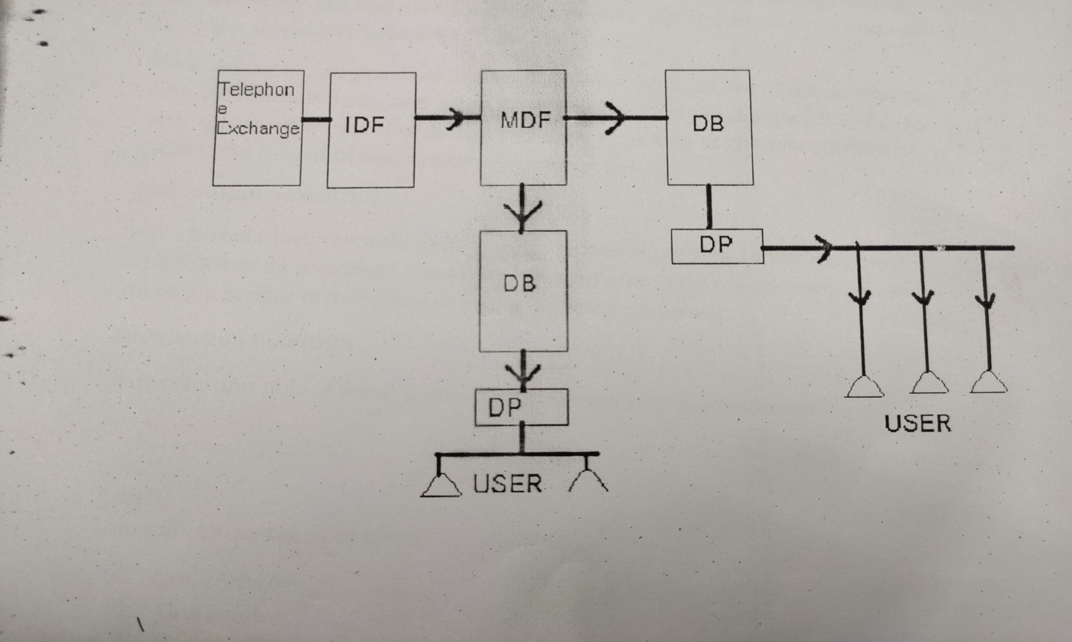

* GM Intercom system
* Capacity-104 lines
* Current users-96
* Components

1)CPU card

2)Line card

3)BTU card

* Railnet System
* Bandwidth- 1 Gbps
* User - 1875
* Component-

1) Router

2) UTM

3)Switch

4) Media converter

5) Wi-Fi router

6) OFC

* PDSLAM System
* Bandwidth- 250 Mbps
* Capacity- 264 lines
* Current user - 203
* Component –

1)Router

2)ADSL line card

3) ADSL splitter card

4)ADSL modem

* PA System
* PA system installed at exchange for announcing in workshop.
* GM conference hall PA system
* Hall of fame PA system
* Video conferencing system
* TTC auditorium PA system
* TTC seminar hall PA system
* BLW cinema hall PA system
* Internet
* Railnet System
* IPDSLAM system
* PA system installed at exchange for announcing in workshop.
* Component

1)Amplifier

2)Mixer

3)Horn/speaker

4)Mike

5)DVD player

* PA system of GM conference hall & Hall of fame
* Components

1) Delegate unit

2) CCU

3) Mixer

4) Suppressor

5) Amplifier

6) Speaker

* PRS
* BLW PRS TOT building.
* Cash PRS central market.
* Video conferencing system
* Component

1)Media converter

2)Modem

3)Codec

4)Camera

5)Table top mike

* CCTV cameras
* There are total 242 Nos. CCTV cameras installed in BLW premises monitored by RPF in security control room BLW.

Details of CCTV cameras

* Static camera - 228 nos.
* PTZ camera - 08nos.
* ANPR camera -08nos.
* There are total 32 nos. CCTV cameras installed in BLW hospital (28 nos. central hospital+04nos. Health unit jalalipatti) monitored by hospital administration.
* There are total 08 nos. CCTV cameras installed in BLW cinema hall monitored by cinema club administration.
* There are total 05 nos. CCTV cameras installed in BLW swimming pool monitored by sports cell administration.
* Television /DTH connections
* Total number of TV/DTH connections-89 nos.
* Location
* Kolkata rest house
* ANVR New Delhi
* OGH BLW
* PRH BLW
* Officer’s chambers
* Diesel camp office

Activities

* Maintenance & operation of AVAYA communication server system.
* Maintenance of all types of Telephone lines (i.e. Rly., BSNL & GM intercom lines).
* Maintenance & operation of Railnet system & Railnet IPDSLAM system.
* Maintenance, operation & supervision of all types of PA system & music system.
* Installation, operation & supervision of PA system on demand at different sites.
* Maintenance of TV & DTH connection.
* Monitoring & supervision of CCTV cameras.
* Maintenance & supervision of BLW PRS & Cash PRS (Central market).
* Operation & supervision of video conferencing system in GM conference hall.
* Material management.
* Putting proposal for new work & monitoring of existing running contractual work.
* Proper arrangement of store & maintaining cleanliness in the store.
* Maintaining records of store items & disposal of scrap items.
* Daily testing of all telephone assets installed at officer’s chambers (SAG & above)
* Daily inspection of working of CCTV cameras in the RPF control room & maintaining records.
* Daily playing the music through workshop PA system in the shop area during break-time & announcing the important information as directed by higher authority.
* Generating new ID for users and providing new internet connections & maintenance of the existing user accounts.
* Changing of defective ports & providing & cancellation of STD facility for user & other programming related work in AVAYA system.
* All programming related work in GM Intercom system.
* Up gradation of telephone directory (pocket directory of BLW officer’s, GM Intercom directory & main directory )in regular interval.
* Call attending, call forwarding & call conferencing as demanded by officers & enquiry related services.
* Provide the information to responsible person (officers related to safety) at the time of emergency condition such as fire & industrial accident.
* Note down the temperature of indoor exchange room on the hourly basis.
* All work related to CUG connection (such as providing new no. SIM to new user & resolving all problem related to subscriber).
* Ensuring the proper N/W of service provider N/W (Reliance JIO)in the BLW premises.
* Maintenance of mobile handset provide to officers.
* Preventive maintenance of other important assets i.e. UPS, charger, batteries etc.
* All other miscellaneous work allotted by higher authority.

Assistance required

* Up gradation of IPDSLAM system.
* Replacements of telephone DB’s.
* Up gradation of Railnet system at firewall side.
* AMC required for CCTV cameras maintenance.
* At least 03 electricians & 02 helpers are required.
* PC, printer & scanner are required.

**Shop 4 – Loco Assembly Shop**

* Tested engines are receives from Engine Division.
* Similarly under frames are received from Loco frame shop and assembled trucks from Truck machine shop.
* Super structure compartments and contractor compartment are received from respective manufacturing and assembly shops of Vehicle Division.
* Important alignments like crank shaft deflection, compressor alignment and Eddy Current clutch/radiator fan alignment are done during assembly stage.
* Electrical control equipments are fitted and control cable harnessing is undertaken.
* The complete locomotive is thus assembled before being sent onwards for final testing and spray painting.
* All locomotive are rigorous tested as per laid down test procedures before the locomotive is taken up for final painting and dispatch for service.

* **Main Alternator**

The diesel engine drives the main alternator which provides the power to move the train. The alternator generates AC electricity which is used to provide power for the traction motors mounted on the trucks (bogies). In older locomotives, the alternator was a DC machine, called a generator. It produced direct current which was used to provide power for DC traction motors. Many of these machines are still in regular use. The next development was the replacement of the generator by the alternator but still using DC traction motors. The AC output is rectified to give the DC required for the motors.

* **Auxiliary Alternator**

Locomotives used to operate passenger trains are equipped with an auxiliary alternator. This provides AC power for lighting, heating, air conditioning, dining facilities etc. on the train. The output is transmitted along the train through an auxiliary power line. In the US, it is known as "head end power" or "hotel power". In the UK, air conditioned passenger coaches get what is called electric train supply (ETS) from the auxiliary alternator.

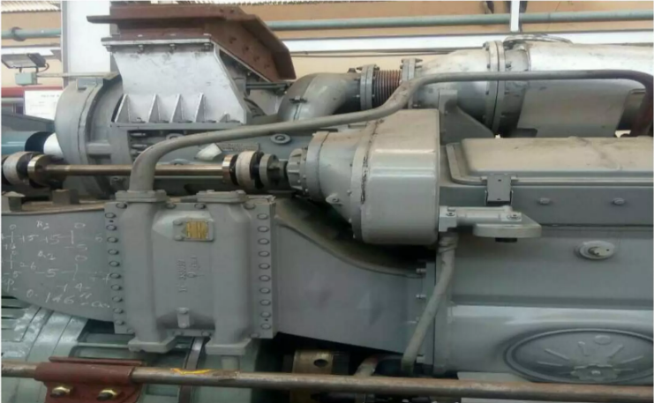

Auxiliary Generator

* **Air Intakes**

The air for cooling the locomotive's motors is drawn in from outside the locomotive. It has to be filtered to remove dust and other impurities and its flow regulated by temperature, both inside and outside the locomotive. The air management system has to take account of the wide range of temperatures from the possible +40°C of summer to the possible -40°C of winter.

* **Rectifiers/Inverters**

The output from the main alternator is AC but it can be used in a locomotive with either DC or AC traction motors. DC motors were the traditional type used for many years but, in the last 10 years, AC motors have become standard for new locomotives. They are cheaper to build and cost less to maintain and, with electronic management can be very finely controlled. To convert the AC output from the main alternator to DC, rectifiers are required. If the motors are DC, the output from the rectifiers is used directly. If the motors are AC, the DC output from the rectifiers is converted to 3-phase AC for the traction motors.

* **BATTERIES**

Traction Motor Since the diesel-electric locomotive uses electric transmission, traction motors are provided on the axles to give the final drive. These motors were traditionally DC but the development of modern power and control electronics has led to the introduction of 3- phase AC motors. For a description of how this technology work. There are between four and six motors on most diesel-electric locomotives.

* **Fuel Tank**

A diesel locomotive has to carry its own fuel around with it and there has to be enough for a reasonable length of trip. The fuel tank is normally under the loco frame. The capacity of fuel tank is between 4500 ltrs. to 6000 ltrs(20-cylinder) it is vary according to the model of engine.

* **Traction motor Pinion/Gear**

The traction motor drives the axle through a reduction gear of a range between 3 to 1 (freight) and 4 to 1 (passenger).

* **Air Compressor**

The air compressor is required to provide a constant supply of compressed air for the locomotive and train brakes. Drive Shaft The main output from the diesel engine is transmitted by the drive shaft to the alternators at one end and the radiator fans and compressor at the other end. Radiator and Radiator Fan The radiator works the same way as in an automobile. Water is distributed around the engine block to keep the temperature within the most efficient range for the engine. The water is cooled by passing it through a radiator blown by a fan driven by the diesel engine. Sand Box Locomotives always carry sand to assist adhesion in bad rail conditions. Sand is not often provided on multiple unit trains because the adhesion requirements are lower and there are normally more driven axles. Truck Frame This is the part (called the bogie) carrying the wheels and traction motors of the locomotive.

* **TRUCK FRAME Mechanical Transmission**

A diesel-mechanical locomotive is the simplest type of diesel locomotive. As the name suggests, a mechanical transmission on a diesel locomotive consists a direct mechanical link between the diesel engine and the wheels. In the example below, the diesel engine is in the 350-500 hp range and the transmission is similar to that of an automobile with a four speed gearbox. Most of the parts are similar to the diesel-electric locomotive but there are some variations in design mentioned below.

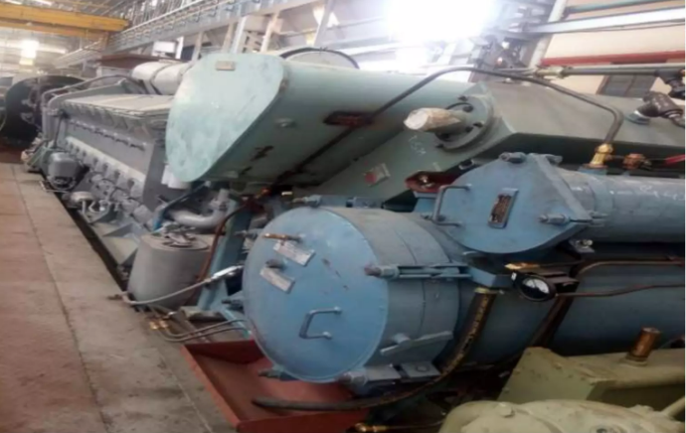

Rack Arrangement

* **Wheel Slip**

Wheels slip is the bane of the driver trying to get a train away smoothly. The tenuous contact between steel wheel and steel rail is one of the weakest parts of the railway system. Traditionally, the only cure has been a combination of the skill of the driver and the selective use of sand to improve the adhesion. Axle, wheel & Gear assembly with Traction Motor These wheels are having wear adapted profile to RDSO drawing. ELECTRICAL CONTROL CABINET (ECC) ECC 1 –Power distribution and converts DC current into AC current for traction motors. ECC 2 – For battery charging assembly ECC 3 – Radiator controlling system ECC 4 –For communication between CAB1 and CAB2 , In twin cab engines Engine can be started from both of the cabs TRACTION CONTROL CABINET (TCC) TCC 1 –Control traction motors of bogie 1 TCC 2 – control traction motors of bogie 2.

* Short notes on LAS
* Tested engines are received from engine division.
* Similarly under frames are received from Loko frame shop and assemble truck from truck machine shop.
* Superstructure compartments and contractor s who compartment received from respective manufacturing and assembly shops of vehicle division.
* Important alignments like crank shop deflection compressor alignment in AD current clutch or radiator when alignment are done during assembly stage.
* Electrical control equipments are fitted and control cable harnessing is undertaken.
* The complete locomotive is the assemble before being sent onwards for final testing and spray painting.
* All locomotive are rigorous tested as per late down test procedure before the locomotive is taken upper final painting and dispatch for service.

# **Conclusion**

The Four weeks Training program lasted from 04-June-2024 to 01-July-2024 with one week each spent at SCADA, TAS, Tele. Exchange, LAS.

The training program was very fruitful and I got to learn about various new devices and process undertaken at an industry. My interactions with the industry professionals gave me an idea of practical life of an engineer.

**BIBLIOGRAPHY**

1. [www.indianrailways.gov.in](http://www.indianrailways.gov.in)

**2.** Cris-BLW.cirs.org.in

**3.** www.irfca.org